5.1 Introduction.

The game “Monkey See Monkey Guess” was developed as a new take on the classic game of charades, incorporating media into the mechanics to create a new game.

As spin-off game, “Monkey See Monkey Guess” makes a great and fun experience when played by three or more players where a player is to show the other players an image associated with the chosen topic and the other players have to guess the title of.

5.2 Materials

The task required players to use media to play the game and for that it was required to have a device that could access media images from the internet.

The items needed to play the game were:

* A device capable to display images (preferably with access to internet).
* Timer to track time per each round (Figure 1.) ( <https://www.online-stopwatch.com/> ).
* Wheel spinner to pick words ( <https://www.online-stopwatch.com/random-name-pickers/name-picker-wheel/?r=MuRGyi1Hhb> ).
* A pad (Figure 3) to record player scores as game progresses.
* A set with different topics (Figure 2).

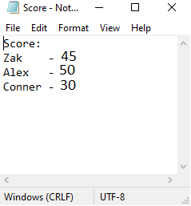

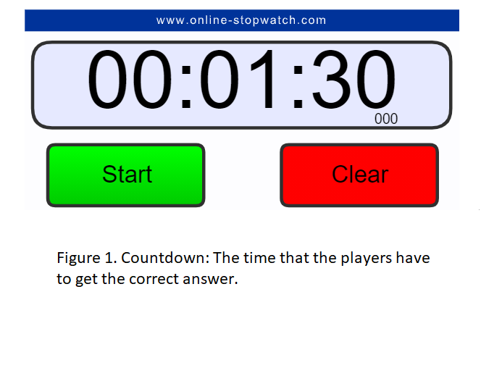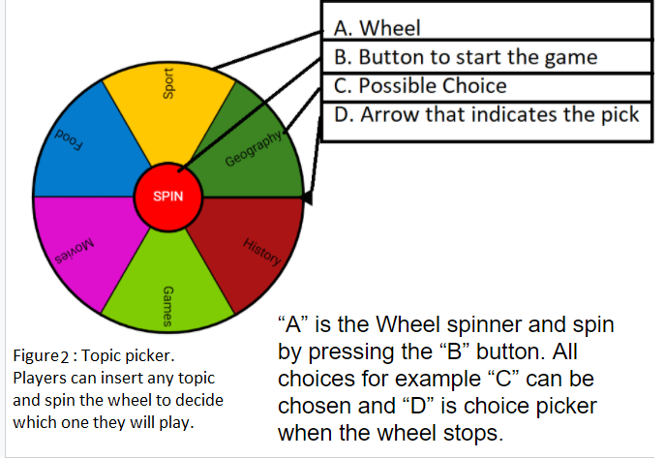

Figure 3. Score board:

Notepad to keep track of the score

5.3 Rules

* Players could not use images that contained a direct reference to the topic (i.e. character from the movie)
* Each round had 1 minute and 30 seconds
* If a player guessed correctly, they won 10 points; if no player got a correct answer, everyone lost 5 points
* The game was played in turns and clockwise.
* First player to get to 50 points wins.

5.4 Gameplay

The game started once the group decided the main topic of the game (see Figure 2.) and “The Leader” (player showing the images) chose from the assigned loadouts or created his/her own.

With the topic decided, “The Leader” spun the wheel (Figure 4) to pick a random title from the board.

Once a title was selected, the countdown of 1 minute and 30 seconds started and “The Leader” needed to browse for an image that acted as a hint for other players to guess correctly.

Players had to guess the “Title” of the chosen topic to win points accordingly.

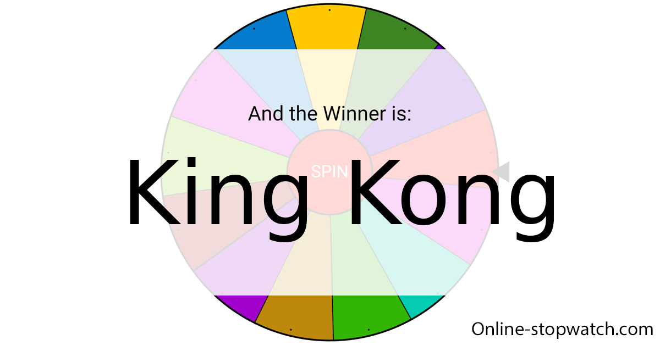

Figure 4. Guess the movie: The wheel has stopped

spinning and a title has been randomly chosen.

5.5 Playtest and teams

The team was easy to work with, active and each member had a big involvement in the development process. The part that I helped with involved the creation of the wheel with possible choices, capturing the game images and also added some extra details in rules and gameplay.

The internal playtest of the game was entertaining however, one of the issues experienced was that a poor internet connection was slowing down the game. The issue was resolved by having an album of images downloaded on the device at the beginning of the game.

Another issue was the repeating games with the same chosen “Topic”. This was resolved by spinning the wheel again, until a new unplayed object was selected.

During the external playtesting, the feedback was positive and the game was classed as easy to understand and quick to play. “I like the fact that the rounds were quick and the game easy to understand” Adam.

Although I was quite happy with the overall experience, the game could have included some extra options such as having the images directly on the spinning wheel and having the already picked images deleted from the wheel.

5.6 Members of the team:

Zakaria Ahmed, Connor Hadley and I, Alexandru Zarnescu